UNIT – 4
Solid state Physics
Unit-04/Lecture-1
Kronig Penny Model:- [RGPV/Dec2012(14),Dec2013(7),June2011(10)]
The Kronig penny model illustrates the behaviour of an electron in a periodic potential. According to Kronig Penny, the potential of an electron in a linear array of positive nuclei has a form of periodic square potential.

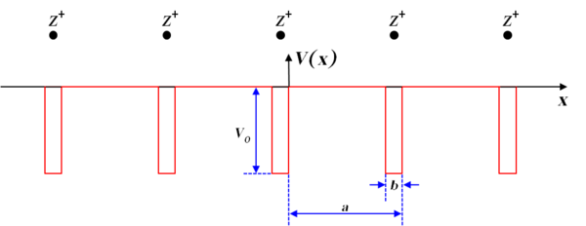

This potential consists of an infinite row of rectangular wells separated by barriers of width b with space periodicity (a+b). Each well represents an approximation to the potential produced by an ion. In region such as 0<x< (a-b) the potential energy is equal to zero and the region such as –b<x<0 it is V₀.

Although, the periodic potential is somewhat idealized and is only approximation to be found in actual crystals but it illustrates many important features of the behaviour of electron in periodic lattice.
The Schrodinger equation for electron in a crystal lattice may be written as,

d²ψ/dx²+2m/ħ²(E-V₀)ψ =0 -b<x<0------------(i)
Here, E is the energy of electron in periodic lattice and V₀ is the crystal barrier.
The solution of equation (i) is possible only for energies given by the relation
$\frac{ Psin∝a}{∝a}+ cos∝a=coska$---------------(ii)
$P=\frac{mV_{0}ab}{ħ^{2}}$ and |$∝=\frac{\sqrt{2mE}}{ħ}$

Equation (ii) will be satisfied for those values of $∝$ for which left hand side lies between +1 and -1 because the value of right hand side may be +1or -1. Such values of $∝a$ will represent the wave like solution of equation (ii) and are allowed. Other values of $∝a$ are not allowed.

If a graph is plotted between $∝a$ and $\frac{ Psin∝a}{∝a}+ cos∝a$ for P=3π/2, by taking $∝a$ along x axes and $\frac{ Psin∝a}{∝a}+ cos∝a$ is along y axes following conclusion can be drawn.
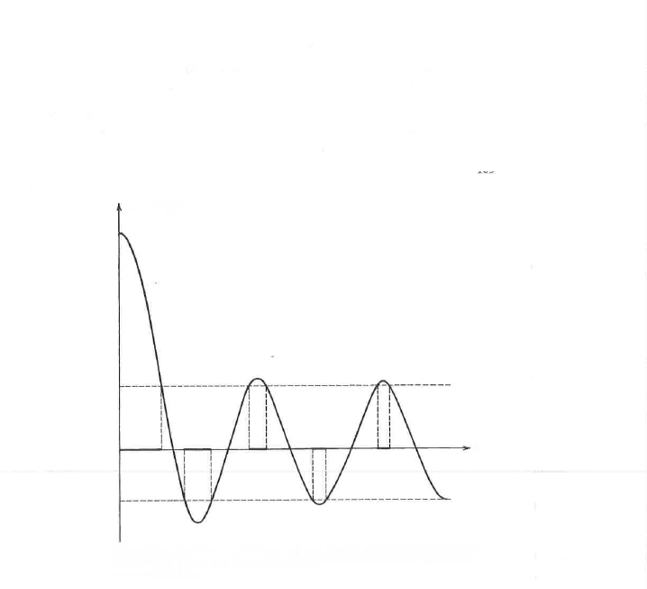
- The energy spectrum of the electron consists of alternate regions of allowed and unallowed energy. The allowed ranges of $∝a$ which permit a wave mechanical solution to exist. So the motion of electrons is characterized by bands of allowed energy separated by forbidden regions.
- As the value of $∝$ increases, width of allowed bands also increases and width of forbidden band decreases.
- When potential barrier strength P is large, the function of left hand side of the equation of equation (ii) crosses +1 and -1 region at a steeper angle. Therefore, the allowed bands become narrower and forbidden bands become wider.
- When P→0
$$\cos{∝a=coska}$$
$∝=k$
$$∝^{2}=k^{2}$$

$$\frac{2mE}{ħ^{2}}=k^{2}$$
Or $E=\frac{k^{2}ħ^{2}}{2m}$
This energy corresponds to a completely free particle. So no energy bands exist this case i.e. all energies are allowed to electrons. Thus varying P from 0 to ∞
S.No. | Question | year | Marks
1 | Describe the behaviour of an electron in periodic potential using final expression of Kronig Penny Model | Dec2013 | 7
2 | Draw periodic potential observed by an electron. Moving in one dimensional crystal lattice. Discuss Kronig Penny Model proposed for periodic Potential. Write Schrödinger wave equation for such potential and discuss its solution. | Dec2012 | 14
We find that completely free electro becomes completely bound.

Unit-02/Lecture-2

Effective Mass:- [RGPV/June 2011 (5),June 2013(14)]
An electron has well defined mass m. When it is placed in an external field, it obeys Newtonian mechanics. The acceleration is given by
$a=\frac{eE}{m}$ ...............(i)
Where e is change of electron, m is mass, E is applied electric field
The inertial mass of a particle may be defferent from the true mass. So it is with electrons in periodic structures, because an electron in a crystal cannot strictly be treated in isolation (it forms a system jointly with the lattice), the momentum of such an electron is not a true momentum, but a crystal momentum and, as such, momentum may be transferred freely between electron and lattice. As a result, it is not expected that the eﬀective inertial mass m*_{e} of an electron in a translational periodic solid should be the same as the bare electron mass m_{e}. The eﬀective mass depends on the geometry of the electronic band structure, being related to the curvature of the bands in k-space.

“When an electron in a periodic potential of lattice is accelerated by an electric field or magnetic field, then the mass of the electron is called effective mass (m_{e}*).”
According to de –Broglie idea, an electron moving with velocity is considered as a wave packet moving with the group velocity V_{g}, which is equal to a particle velocity.

$V_{g}=\frac{dω}{dk}=\frac{2π}{h}\frac{dE}{dk}$ ..................(ii)
Where E=hν=ħω
The acceleration (a) of this electron is given by
$a= \frac{2π}{h} \frac{d}{dt}\left(\frac{dE}{dk}\right)$ ...................(iii)
$a=\frac{2π}{h}\frac{d^{2}E}{{dk}^{2}}\left(\frac{dk}{dt}\right)$ ...............(iv)
The quantity $(\frac{d^{2}E}{{dk}^{2}})$ can easily be evaluated from E-k curve. Now we have to find the value of $\frac{dk}{dt}$ under the influence of an applied field.
Let the electron is subjected to the influence of an external field of strength E for a time dt. If the velocity of electron is V_{g}, the distance travelled in time dt is V_{g}dt. The work done dE is given by
$$dE=eEV_{g}dt$$
$$dE=eE \left[\left(\frac{2π}{h}\right)\left(\frac{dE}{dk}\right)\right]dt$$

$\frac{dk}{dt}= \left(\frac{2π}{h}\right)eE$....................(v)
Substituting the value of $\frac{dk}{dt}$ from eq. (v)in eq. (iv)
$a= \frac{2π}{h}\frac{d^{2}E}{{dk}^{2}}\left[\frac{2π}{h}eE\right]$...............(vi)

$a=\left(\frac{{4π}^{2}}{h^{2}}\right)eE\left(\frac{d^{2}E}{{dk}^{2}}\right)=\frac{eE\left(\frac{d^{2}E}{{dk}^{2}}\right)}{\left(\frac{h^{2}}{{4π}^{2}}\right)}$.........................(vii)
In case of free classical particle
$$e\frac{dv}{dt}=eE$$
or$\frac{dv}{dt}=a=\frac{eE}{m}$
$a=\frac{eE}{m}$................(viii)

On comparing equation (vii) and (viii)
$m_{e}^{*}$=$\frac{ \left(\frac{h^{2}}{{4π}^{2}}\right)}{\frac{d^{2}E}{{dk}^{2}}}$
Or
$m_{e}^{*}$=$\frac{ ħ^{2}}{\frac{d^{2}E}{{dk}^{2}}}$
This expression shows that the effective mass is determined by$\frac{d^{2}E}{{dk}^{2}}$, i.e. effective mass of electron is not constant but it depends on the value of $\frac{d^{2}E}{{dk}^{2}}$ (shape of E-k curve).
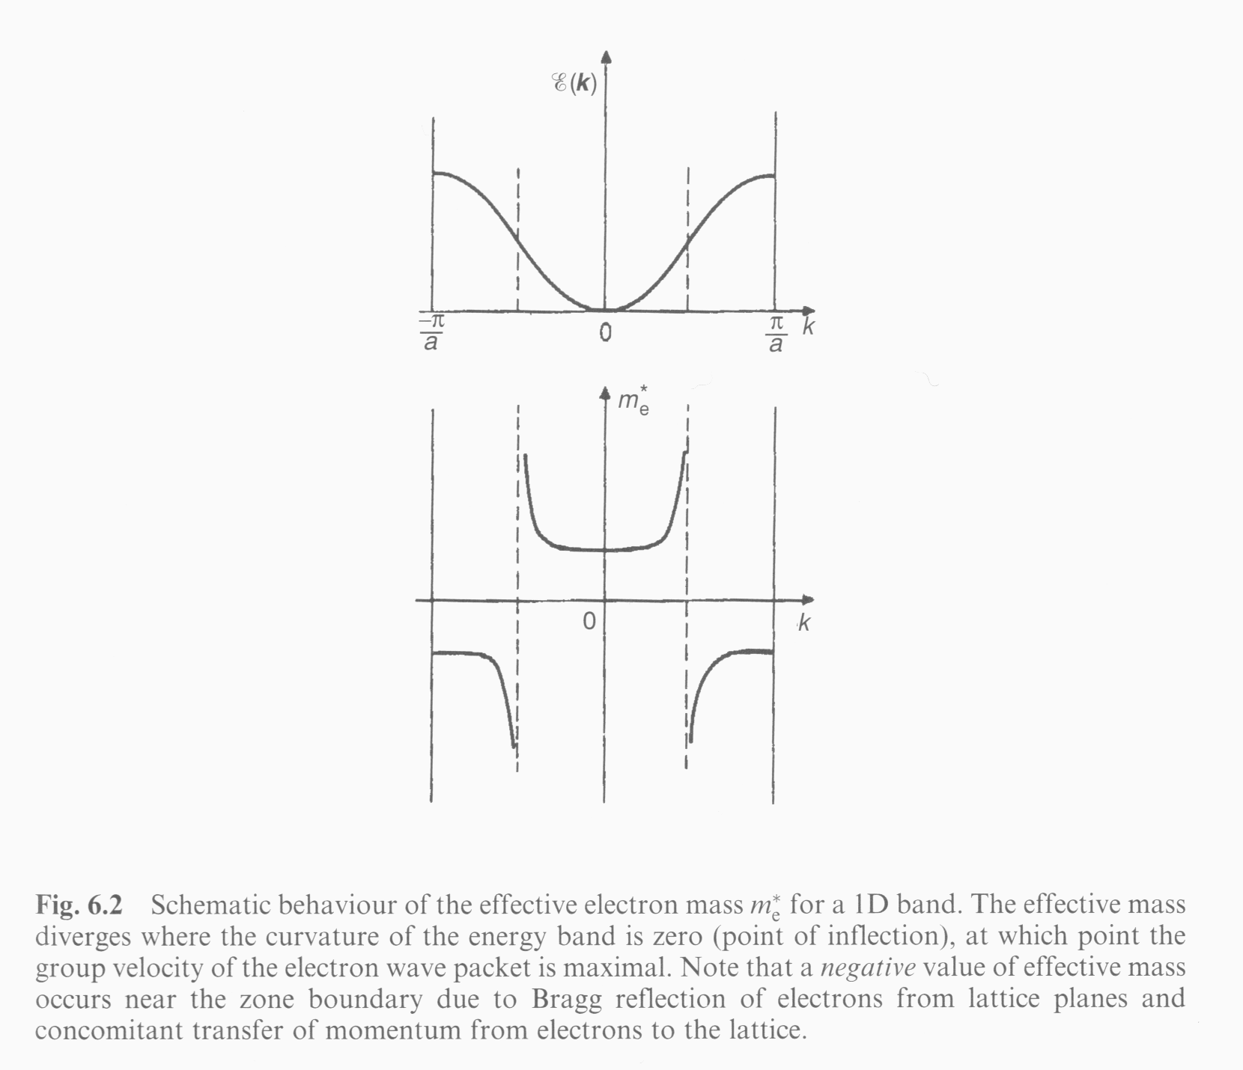
From the graph, we observe following points:
- Near k=0, effective mass approaches m.
- As value of k increases, the effective mass m* increases, and reaches its maximum value at the point of inflection on E-k curve.
- Above point of inflection, m* is negative and k→π/a, it decreases to a small negative value.
Therefore, near the bottom of the band, the effective mass m* has constant positive value. It is important to mention here that beyond the point of inflection, the effective mass m* becomes negative. So the m* may be greater, or smaller or even negative than the mass m of electron.

S.No. | RGPV Question | year | marks
1 | Draw E-K curve for an electron moving in periodic potential. Define effective mass (m_{e}*) and prove that effective mass of an electron is given by $m_{e}^{*}$=$\frac{ ħ^{2}}{\frac{d^{2}E}{{dk}^{2}}}$ and its significance. | June 2013 | 14
2 | Write a short note on effective mass. | June 2011 | 5

Unit-04/Lecture-3
Hall Effect [RGPV/June2012(14),Dec2012(10),Dec2011(5)]

When a metal or semiconductor carrying current I is placed in transverse magnetic field B, then a potential is developed in the metal or semiconductor in the direction perpendicular to both I and B. The phenomenon is known as Hall effect.
Suppose a bar of material carrying current I in the positive X direction. Let the magnetic field B is applied in the positive Z direction. The width and thickness of the bar are w and t respectively.
The charge carriers experience a deflecting force in downward direction i.e. in negative Y direction. This causes negative charges to accumulate on the bottom face while positive ions are collected at upper face. This separation of charges sets up an electrostatic field inside the conductor in Y direction. This is called Hall field E_{H} and the effect is called Hall effect.

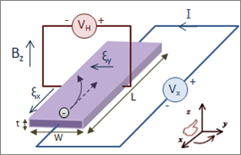

Hall Voltage and Hall Coefficient :
The force on electron due to electric field =$-eE_{H}$
The force on electron due to magnetic field =$-ev_{x}B_{z}$
In equilibrium $eE_{H}=ev_{x}B_{z}$
$E_{H}=v_{x}B_{z}$ ...........(i)
The current density $J_{X}$ in X direction is given by
$J_{X}= -nev_{x}$ or $v_{x}=-J_{x}/ne$ ..............(ii)
Where n is the charge carrier current density, i.e., number of charge carriers per unit volume.
Substituting the value of $v_{x}$ from eq (ii) in eq.(i), we get
$E_{H}=- \left(\frac{J_{x}}{ne}\right)B_{z}= -\left(\frac{1}{ne}\right)J_{x}B_{Z}$....................(iii)
This equation shows that Hall field $E_{H}$is proportional, both to current density(or current)
And on magnetic field. The proportionality constant is usually denoted by$R_{H}$.
Thus, we have
$\frac{E_{H}}{J_{x}B_{z}}= -\frac{1}{ne}=R_{H}$...............(iv)

$R_{H}$ is known as Hall coefficient.
Let us express the Hall electric field $E_{H}$ in terms of Hall potential difference$V_{H}$. Let $y$ and z are the thickness and width of the bar along Y and Z axes respectively.
$$E_{H}= \left(\frac{V_{H}}{y}\right)$$
From eq.(iv) $\frac{\frac{V_{H}}{y}}{J_{x}B_{z}}= R_{H}$

$V_{H}=J_{x}B_{z}R_{H}y$.....................(v)
Further $J_{x}=\left(\frac{I_{x}}{yz}\right)$

$V_{H}=\left(\frac{I_{x}}{yz}\right)B_{z}R_{h}y= \frac{I_{x}B_{z}R_{H}}{z}$
Therefore $R_{H}= \frac{V_{H}z}{I_{x}B_{z}}$

Importance of Hall effect
- The sign of charge carriers can be determined.
- Charge carrier concentration (n) can be determined.

S.No. | RGPV Questions | Year | Marks
1 | What is Hall effect? Deduce an expression for Hall Coefficient of a solid and describe method for its determination experimentally? What important information are obtained from its measurement? | Dec2012 | 10
2 | What is Hall effect? Show that Hall coefficient is independent of applied magnetic field and is inversely Proportional to current density and electronic charge. | June 2012 | 14
3 | What is Hall Effect? | Dec 2011 | 5

Unit-04/Lecture-4
Fermi Dirac Distribution Function:-
The expression that governs the distribution of electrons among the energy levels as a function of temperature is known as Fermi Dirac statistical distribution function. This function is denoted by$f\left(E\right)$ and is given by
$$f\left(E\right)= \frac{1}{1+e^{\frac{\left(E-E_{F}\right)}{kT}}}$$
The function $f\left(E\right)$ indicates the probability that a particular energy state at the energy level $E$ is occupied by an electron. Here${ E}_{F}$ is Fermi level or characteristic energy in eV, $k$is Boltzmann constant and $T$ is temperature in K. The function $f\left(E\right)$determines the carrier occupancy of the energy states.
Now consider the following cases:-
- When $E{< E}_{F}$ and $T=0K$ than
$$f\left(E\right)= 1$$
So, we conclude that all energy levels with energies less than $E_{F}$ will be occupied at absolute zero.
- When $E{> E}_{F}$ and $T=0K$ than
$$f\left(E\right)= 0$$
So, there is no probability of finding an occupied quantum state of energy greater than ${ E}_{F}$ at absolute zero.
- At any temperature $T$ and for $E{=E}_{F}$

$$f\left(E\right)= 1/2$$
The energy level corresponding to $E{=E}_{F}$ is called as Fermi level. So the Fermi level at which there is $\frac{1}{2}$ Probability of finding electron.
Therefore, Fermi energy level is defined as the energy level in a solid below which all energy levels are filled and all the levels above this are empty.
Fermi level for intrinsic semiconductor:
In an intrinsic semiconductor number of electron in conduction band$n$ are equal to number of holes in valance band $p$

i.e.
$$n=p$$

$N_{c}e^{\frac{{-[E}_{c}-E_{f}]}{kT}}=N_{v}e^{\frac{{-[E}_{f}-E_{v}]}{kT}}$.....................(i)
Taking log of both the sides and rearranging the terms we get

$logN_{c}-\frac{E_{c}-E_{f}}{kT}=logN_{v}-\frac{E_{f}-E_{v}}{kt}$....................(ii)

Where $N_{c}={2[\frac{2πm_{e}^{*}kT}{h^{2}}]}^{3/2}$

$$N_{v}={2[\frac{2πm_{h}^{*}kT}{h^{2}}]}^{3/2}$$
Where $m_{e}^{*}=effective mass of electrons$
$$m_{h}^{*}=effective mass of holes$$
$h=plank constant$
$T$=Absolute temperature
$$k=Boltzmann constant$$
$$-E_{c}+E_{f}=kTlog\left(\frac{N_{v}}{N_{c}}\right)-E_{f}+E_{v}$$
$${2E}_{f}-E_{c}-E_{v}=kTlog\left(\frac{N_{v}}{N_{c}}\right)$$
$${2E}_{f}=kTlog\left(\frac{N_{v}}{N_{c}}\right)+E_{c}+E_{v}$$

$$E_{f}=\frac{kT}{2}log\left(\frac{N_{v}}{N_{c}}\right)+\left(\frac{E_{c}+E_{v}}{2}\right)$$
Substitute the value of $N_{c}$and $N_{v}$

$$E_{f}=\frac{kT}{4}log\left(\frac{m_{e}^{*}}{m_{h}^{*}}\right)+\left(\frac{E_{c}+E_{v}}{2}\right)$$
In pure semiconductor $m_{e}^{*}=m_{h}^{*}$ so

$$E_{f}=\left(\frac{E_{c}+E_{v}}{2}\right)$$

$$E_{f}=\left(\frac{E_{c}+E_{v}}{2}\right)$$

$$E_{f}=\left(\frac{E_{c}+E_{v}+E_{v}-E_{v}}{2}\right)$$

$$E_{g}=\left(E_{c}-E_{v}\right)$$

So

$E_{f}=\frac{E_{g}}{2}+E_{v}$
$E_{v}=0$ (for intrinsic semiconductor)
So $E_{f}=\frac{E_{g}}{2}$
So in pure semiconductor Fermi level lies in the middle of forbidden gap.

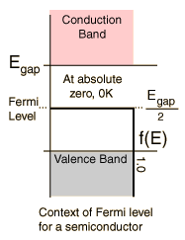

Fermi level for extrinsic semiconductor
In n type semiconductor:-

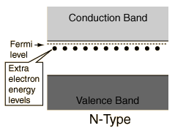
In n type semiconductor number of electrons in conduction band is more than number of holes in valence band so the Fermi level is shifted towards conduction band.

In p type semiconductor:-

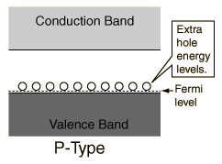

In p type semiconductor number of holes in valence band is more than number of electrons in conduction band so the Fermi level is shifted towards valence band.

Unit-04/Lecture-05
PN junction diode[RGPV/Dec2011(7)]

A PN Junction Diode is one of the simplest semiconductor device around, and which has the characteristic of passing current in only one direction only. However, unlike a resistor, a diode does not behave linearly with respect to the applied voltage as the diode has an exponential current-voltage ( I-V ) relationship and therefore we cannot described its operation by simply using an equation such as Ohm’s law.
If a suitable positive voltage (forward bias) is applied between the two ends of the PN junction, it can supply free electrons and holes with the extra energy they require to cross the junction as the width of the depletion layer around the PN junction is decreased.

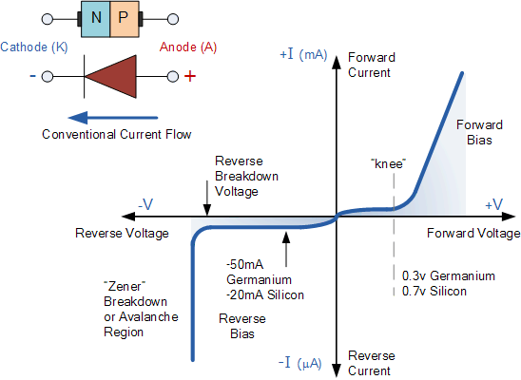

There are two operating regions and three possible “biasing” conditions for the standard Junction Diode and these are:
- Zero bias – No external voltage potential is applied to the PN junction diode.
- Reverse Bias – The voltage potential is connected negative, (-ve) to the P-type material and positive, (+ve) to the N-type material across the diode which has the effect of Increasing the PN junction diode’s width.
- Forward Bias – The voltage potential is connected positive, (+ve) to the P-type material and negative, (-ve) to the N-type material across the diode which has the effect of Decreasing the PN junction diode’s width.
The PN junction region of a Junction Diode has the following important characteristics:
- Semiconductors contain two types of mobile charge carriers, Holes and Electrons.
- The holes are positively charged while the electrons negatively charged.
- A semiconductor may be doped with donor impurities such as Antimony (N-type doping), so that it contains mobile charges which are primarily electrons.
- A semiconductor may be doped with acceptor impurities such as Boron (P-type doping), so that it contains mobile charges which are mainly holes.
- The junction region itself has no charge carriers and is known as the depletion region.
- The junction (depletion) region has a physical thickness that varies with the applied voltage.
- When a diode is Zero Biased no external energy source is applied and a natural Potential Barrier is developed across a depletion layer which is approximately 0.5 to 0.7v for silicon diodes and approximately 0.3 of a volt for germanium diodes.
- When a junction diode is Forward Biased the thickness of the depletion region reduces and the diode acts like a short circuit allowing full current to flow.
- When a junction diode is Reverse Biased the thickness of the depletion region increases and the diode acts like an open circuit blocking any current flow, (only a very small leakage current).

ZENER DIODE:- [RGPV/June2012(14)]

A Zener diode is a diode which allows current to flow in the forward direction in the same manner as an ideal diode, but also permits it to flow in the reverse direction when the voltage is above a certain value known as the breakdown voltage," Zener knee voltage", "Zener voltage", "avalanche point", or "peak inverse voltage".
With the application of sufficient reverse voltage, a pn junction will experience a rapid avalanche breakdown and conduct current in the reverse direction. Valance electrons which break free under the influence of the applied electric field can be accelerated enough that they can knock loose other electrons and the subsequent collisions quickly become an avalanche. When this process is taking place, very small changes in voltage can cause very large changes in current. The breakdown process depends upon the applied electric field, so by changing the thickness of the layer to which the voltage is applied, zener diode can be formed which break down at voltages from about 4 volts to several hundred volts.
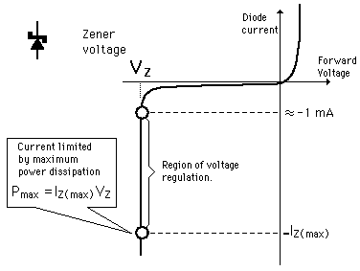

The Zener Diode goes through a number of different regions or stages, of which are explained below.
Forward characteristics:-The right half side of the characteristics curve is the part in which the zener diode receives forward voltage, which is the positive voltage across its anode to cathode terminals. The diode in this region is in forward biased. During this period, the current is small for a while until it spikes exponentially up once the voltage reaches a certain point, called the threshold voltage.
Revese characteristics:-The left half side of the characteristics curve is the more important part, when considering zener diodes. This is the part in which the zener diode receives positive voltage across its cathode to anode terminals. The diode in this region is in reverse biased. At first, when receiving reverse voltage, the current is very small. There is only a small current, called the leakage current, flowing through the diode. Once it hits the breakdown voltage, the current drastically increases. This current is the called the avalanche current, because it spikes so drastically up. The breakdown voltage point is also important, not just because of the avalanche current, but more importantly because once the voltage of the zener diode has reached this point, it remains constant at this voltage, even though the current across it may increase largely. This makes the zener diode useful in applications such as voltage regulation.
Zener diode as Voltage Regulator
The zener diode uses a p-n junction in reverse bias to make use of the zener effec, which is a breakdown phenomenon which holds the voltage close to a constant value called the zener voltage. It is useful in zener regulators to provide a more constant voltage, for improvement of regulated power supply, and for limiter applications
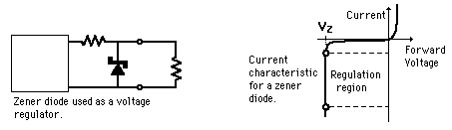

Tunnel Diode:- [RGPV/June2013(7)]

The tunnel diode is a semiconductor device using the same materials as other forms of diode and active devices, the very high levels of doping used, cause the devices to operate in a very different manner.
The device theory shows that it does not act as a diode, but instead exhibits a negative resistance region in the forward direction.

Characteristics:-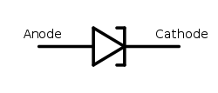
Forward Characteristics:-
Under normal forward bias operation, as voltage begins to increase, electrons at first tunnel through the very narrow p–n junction barrier because filled electron states in the conduction band on the n-side become aligned with empty valence band hole states on the p-side of the p-n junction. As voltage increases further these states become more misaligned and the current drops – this is called negative resistance because current decreases with increasing voltage. As voltage increases yet further, the diode begins to operate as a normal diode, where electrons travel by conduction across the p–n junction, and no longer by tunnelling through the p–n junction barrier. The most important operating region for a tunnel diode is the negative resistance region.

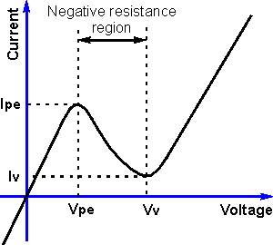

Reverse characteristics :-
When used in the reverse direction, tunnel diodes are called back diodes (or backward diodes) and can act as fast rectifiers with zero offset voltage and extreme linearity for power signals (they have an accurate square law characteristic in the reverse direction). Under reverse bias, filled states on the p-side become increasingly aligned with empty states on the n-side and electrons now tunnel through the pn junction barrier in reverse direction.

S.NO | RGPV QUESTIONS | Year | Marks
Q.1 | Draw neat energy band diagram of symmetrically doped p-n junction diode when it is Unbiased, forward bias and reverse bias. | Dec 2011 | 7
Q.2 | What is Zener diode? Draw an equivalent circuit of ideal and actual Zener diode. What are its uses? | June 2012 | 14
Q.3 | Explain constructional working, with the help of I-V characteristics for Tunnel diode. | June 2013 | 7

UNIT 4/LECTURE 06
Solar cell:-[RGPV/Dec2013 (7),JUNE2013 (7)]

A solar cell (also called a photovoltaic cell) is basically a pn junction that can generate electrical power; solar cells are usually devices typically illuminated with and are intended to convert solar energy into electrical energy.
It consists of p type chip on which a thin layer of n type material is grown. When solar radiation is incident on the cell, electrons holes are generated in n and p region. The majority of them cannot recombine in the regions. They reach the depletion region at the junction where an electric field due to space charge separate them. Electrons in the p region are drawn into the n region and holes in the n region are drawn. It results in acceleration of charge on the two sides of the junction and produces a potential difference called photo emf. Its magnitude is of the order of 0.5V. The overall power conversion efficiency of single crystalline solar cell ranges from 10 to 30% yielding 10to30mW/cm². If a load is connected across the cell a current flows through it.
It considers a current coming out of the cell to be positive as it leads to electrical power generation.
The power generated depends on solar cell itself and the load connected to it.

I V characteristics
The open circuit V_{oc} is the voltage across the illuminated cell at zero current. The short circuit current is close to the photocurrent while its open circuit voltage is close to turn on voltage of diode as measured on a current scale similar to that of photocurrent The power scale equals to the product of the diode voltage and current and at first increases linearly with the diode voltage but then rapidly goes to zero around the turn on voltage of the diode.
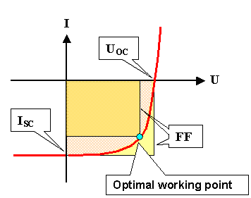

Photo Diode:-[RGPV/JUNE2013 (7)]
Photodiode are crystalline solar cell are essentially the same as the pn junction diode. During the fabrication of the pn diode a depletion layer forms at the junction region by immobile negatively charge acceptor atoms in p type material and immobile positively charged doner ions in the n type materials. The electric field due to these ions stops the motion of majority carriers but accelerates minority carriers across the junction. When a photon is incident on the device an electron holes pairs are generated. In case of electron hole pair generated within the depletion region, the electric field acting across the region causes the pair to separate. This charge separation can be utilized in two ways. If the diode is short circuited externally a current flows between p and n regions. It is known as photoconductive mode of operation. On the other hand, if diode is left on open circuit an externally measurable voltage between p and n region. This is known as photovoltaic mode of operation. This mode of operation is used i solar cells.
When the diode is illuminated light photons are absorbed mainly in depletion layer and also in the neutral region. A photon of energy incident in or near the depletion layer of the diode will excite an electron from the valence band into conduction band. This process generates a hole in the valence band. Thus electron hole pair is generated by optical photon. These are known as photo carriers.
In reverse biased pn junction when a reverse bias is applied across the junction, the depletion layer is widen. The motions of minority carriers’ form reverse leakage current of diode. At zero light the current is dark current.

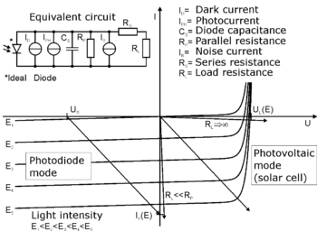

S.NO | RGPV QUESTIONS | Year | Marks
Q.1 | Discuss the basic operation and characteristics of solar cell with necessary diagram. | Dec 2013 | 7
Q.2 | Explain constructional working with the help of I-V characteristics for solar cell, and photo diode. | June 2013 | 14

UNIT 4/LECTURE 7
Superconductivity:-[RGPV/June 2011(5)]
When substance losses its electrical resistance i.e a current can continue through it without changing its value, the phenomenon is called superconductivity.
When the electrical resistance of a substance drops suddenly to zero, when it is cooled below a certain temperature the phenomenon is known as superconductivity.
The substances showing this property are called superconductor, example:- silver (Ag), lead(Pb),
Gallium (Ga) etc.
Temperature dependence of resistivity in superconducting Materials:
Metals are good conductor of electricity as they have plenty of electrons. However they offer resistance to the flow of charges i.e current. Resistance of metals decreases with decrease in temperature.
Metals are superconductors.
The resistance of superconductors in its nonsuperconducting state decreases with decreases in temperature as in case of normal metal. But at a particular temperature T_{c}, the resistivity abruptly drops to zero. T_{c} is called critical temperature.
“The temperature at which a normal material turns into superconductor is called critical temperature.”
The critical temperature is different for different for different conductor. For example Mercury Hg-4.2K, Tungston-.01K.
Effect of external field
It was observed that superconductivity is destroyed if a sufficient strong magnetic field is applied. In other words the superconducting material restores its normal resistance when a strong magnetic field is applied. The minimum magnetic field which is necessary to regain the normal resistivity is called critical magnetic field H_{c}. The minimum value of applied magnetic field when the superconductor losses its superconductivity is called the critical magnetic field. If the applied magnetic field exceeds the critical value H_{c} the superconducting state is destroyed.
It was observed that the normal conducting state of the material is restored, if the magnetic field is greater than its critical value or the temperature of the specimen is raised above critical temperature T_{c}. In other words we can say that for the superconducting state to exist there must be a suitable combination of temperature and magnetic field.
$H_{c}\left(T\right)=H_{c}$(0)$\left[1-\frac{T^{2}}{T_{c}^{2}}\right]$
Where H_{c}(T) is the maximum critical field strength at temperature T. H_{c}(0)is the maximum critical field strength occurring at absolute zero.

S.NO | RGPV QUESTION | YEAR | MARKS
Q.1 | Write short note on superconductivity. | June 2011 | 5

UNIT 4/LECTURE 8
Meissner Effect: :-[RGPV/June 2011(5)]
Meissner observed that if a superconductor is cooled in a magnetic field below the critical temperature corresponding to that field, than the lines of induction are expelled from the material. This effect is known as Meissner Effect.
In its normal state the magnetic lines of forces pass through the superconducting material. But when the specimen is cooled below its critical temperature the magnetic lines of force are expelled out of the specimen.
The expulsion of magnetic lines of force from a superconducting material when it is cooled below the transition temperature in the magnetic field is called Meissner effect.
When T> Tc When T<Tc

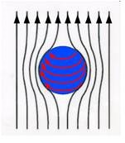
Important points
  - Meissner effect is reversible, when the temperature is increased above T_{c} , the flux suddenly penetrates through the specimen and the substance comes to its normal state.
  - The superconductor is a perfect diamagnet. The reason is that the magnetic induction B in a superconductor is zero.
Therefore for a superconductor
$$B=μ_{o}\left(H+M\right)=0$$

M=-H
H= Magnetic field intensity
M= Intensity of magnetization[ M is defined as magnetic moment per unit volume]
Magnetic susceptibility χ is given by

$$χ=\frac{-H}{H}= -1$$

This is the maximum value of susceptibility of a diamagnetic material. In this sense superconductor is perfect diamagnet.
  - Maxwell’s equation is given by
$$∇×E=-\frac{∂B}{∂T}$$
According to Ohm’s law
$$V=IR$$
And$E=\frac{V}{d}$
$$E=\frac{IR}{d}= \frac{JAR}{d}$$
$$E=Jρ$$
Where$ρ=\frac{AR}{d}$
For finite $J$ and finite $ρ$, e should be Zero

$$\frac{∂B}{∂T}=0$$
B=0
Thus the condition of zero resistivity predicts that magnetic flux should remain constant. This shows magnetic flux should not change when the specimen is cooled. This is contradiction of Meissner effect. Therefore the superconductor should be judged by both the condition independently.

Types of Superconductor:
Superconductors are classified in the following two categories:
- Type I superconductor : type 1 superconductor is one in which the transition from superconducting state to normal state in presence of magnetic field occurs sharply at the critical value H_{c} .
In presence of external field H<H_{c} type I superconductor in superconducting state is a perfect diamagnet. When H exceeds H_{c} the superconductor enters the normal state that means it loses its diamagnetic property completely. In this state the magnetic flux penetrates throughout the superconductor. The critical field value H_{c} for type I superconductor is found to be very low.

- Type II superconductor: Type II superconductor is characterized by two critical fields H_{c1} and H_{c2.}

- For the field strength below H_{c1} the superconductor expels the magnetic field from its body completely and behaves as a perfect diamagnet. H_{c1} is called the lower critical field.
- As magnetic field increases from H_{c1} the magnetic lines begin to penetrate the material. The penetration increases until H_{c2} is reached. H_{c2} is called upper critical field .At H_{c2} magnetization vanishes completely that means the external field has completely penetrate into superconductor and destroyed its superconductivity.
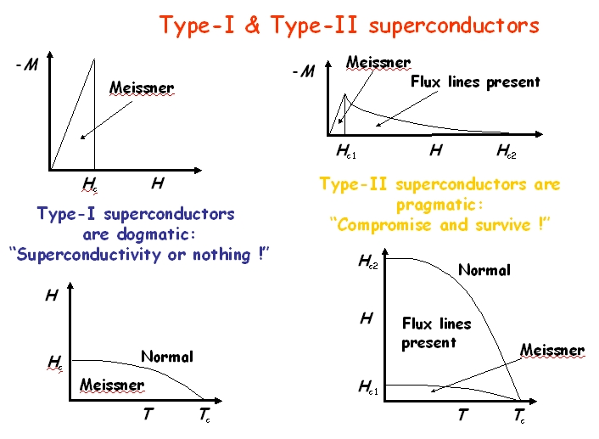

Octane Number of Petrol -
S.NO | RGPV QUESTIONS | Year | Marks
Q.1 | What is superconductivity? Discuss Meissner effect. | Dec 2013 | 7

UNIT 4/LECTURE 9
Dielectrics:- :-[RGPV/June 2012(7)]
Dielectrics are the substances which do not contain free electrons or the number of such electrons is low to constitute the electric current. In dielectrics the electrons are tightly bound to the nucleus of the atom. Mica, glass, plastics are the examples of dielectrics. When such material is placed in electric field it modifies the electric field and acts as a source of storage of electrical charges. Therefore when charge storage is the main function of a material then it is known as dielectrics.
Polar and Nonpolar molecules:-
Atoms consist of positive and negative charges in magnitudes. The positive charge of the nucleus may suppose to be concentrated at a single point called as a centre of positive charge. Similarly the negative charges of the electrons may suppose to be concentrated at a single point called centre of negative charge.
When the two centres of charges coincide the molecule is known as nonpolar molecule.
When the two centres of charges do not coincide the molecule is known as polar molecule. Such molecules have unsymmetrical structure and have a permanent dipole moment.
Non polar dielectric in an electric field
When a dielectric slab is placed in an electric field, the centre of positive charges pulled towards the –ve plate of capacitors and vice versa. Thus the net effect of applied field is to separate the positive charges from the negative charges, this effect is known as the polarization of dielectric.
The dielectrics which are polarized only when they are placed in electric field are called nonpolar dielectrics.
When a dielectric is placed in an electric field surface charges appear and this induced surface charges appear in such a way that the electric field set up by them (E’) opposes the external field E₀, so
E=E₀+E’
Thus if a dielectric is placed in an electric field induced surface charges appear which tend to weaken the original field within the dielectric.
Polar dielectric in an electric field
Polar dielectrics have permanent dipole moment with their random orientation. In presence of electric field the partial alignment of dipoles take place. As the molecules are always in thermal agitation the alignment will never be perfect. The alignment increases with the increases with the increases in electric field or with the decrease in temperature. The dipole moment of polar molecules in an electric field will be P_{p}+P_{i}, where P_{p} is permanent dipole moment and P_{i} is induced dipole moment.

Dielectric polarization:
When a dielectric slab is placed between two metallic plates which can be charged by equal and opposite charges, the negative charges are slightly displaced towards the positively charge plate positively charge nucleus is displaced towards negatively charge plate. This electronic displacement is a function of the magnitude of the charges on plate and the nature of dielectric. In this way the dielectric is acted upon by the forces and is said to be polarized. The distorted atom is called as electric dipole.
The electric dipole moment per unit volume is called dielectric polarization.
Suppose the dielectric slab of area of cross section $A$ and length $l$ is placed in an electric field. If charges on the surfaces are +$q$ and –$q$ than its dipole moment is,
$$p=ql$$
So dielectric polarization $P=\frac{ql}{V}$
$$V=Al$$
So $P=\frac{ql}{Al}=\frac{q}{A}=σ=surface charge density$
Hence surface charge density is equal to surface charge density$σ$.
Dielectric Constant
Coulomb law of the force of attraction
$$F_{1}∝\frac{q_{1}q_{2}}{r^{2}}$$

Where ε₀ is called permittivity of air or vaccum.
If charges are placed in any other medium then
$F_{2}=\frac{1}{4πε}\frac{q_{1}q_{2}}{r^{2}}$……………………….(ii)
Where ε is called permittivity of medium
From (i) and (ii)
$$\frac{F_{1}}{F_{2}}=\frac{ε_{0}}{ε}=\frac{1}{K}$$

$K$is called dielectric constant and defined as the ratio of permittivity of the medium to permittivity of air.

Complex permittivity
A dielectric permittivity spectrum over a wide range of frequencies. ε′ and ε″ denote the real and the imaginary part of the permittivity, respectively. Various processes are labelled on the image: ionic and dipolar relaxation, and atomic and electronic resonances at higher energies.
As opposed to the response of a vacuum, the response of normal materials to external fields generally depends on the frequency of the field. This frequency dependence reflects the fact that a material's polarization does not respond instantaneously to an applied field. The response must always be causal (arising after the applied field) which can be represented by phase difference. For this reason, permittivity is often treated as a complex function of the angular frequency. of the applied field ω: (since complex numbers allow specification of magnitude and phase). The definition of permittivity therefore becomes
where
D₀ and E₀ are the amplitudes of the displacement and electric fields, respectively,
i is the imaginary unit, i² = −1.
The response of a medium to static electric fields is described by the low-frequency limit of permittivity, also called the static permittivity ε_{s} (also ε_{DC} ):
At the high-frequency limit, the complex permittivity is commonly referred to as ε∞. At the plasma frequency and above, dielectrics behave as ideal metals, with electron gas behaviour. The static permittivity is a good approximation for alternating fields of low frequencies, and as the frequency increases a measurable phase difference δ emerges between D and E. The frequency at which the phase shift becomes noticeable depends on temperature and the details of the medium. For moderate fields strength (E₀), D and E remain proportional, and
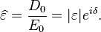
Since the response of materials to alternating fields is characterized by a complex permittivity, it is natural to separate its real and imaginary parts, which is done by convention in the following way:
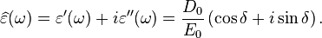
where
ε’ is the real part of the permittivity, which is related to the stored energy within the medium;
ε” is the imaginary part of the permittivity, which is related to the dissipation (or loss) of energy within the medium;
δ is theloss angle.

S.NO | RGPV QUESTION | YEAR | MARKS
Q.1 | Explain how complex permittivity arises in dielectrics. | June 2012 | 7

UNIT 4/LECTURE 10
Definit Dielectric Loss (Loss Tangent):- :-[RGPV/Dec 2013(7)]
Dielectric loss may be defined as the loss of energy in the form of heat by a dielectric medium due to internal friction developed in switching of dipoles to their normal state under the condition of charging or discharging [under a.c. condition].
Let the dielectric material is placed between the plates of capacitor, which is subjected to an alternating electric field. As a result dipoles are engaged in the switching action. The movement of dipoles is opposed by internal friction. This friction is equivalent to the presence of resistance accompanying the capacitor.
We know that in an a.c. circuit containing pure resistance voltage and current remain in the same phase. Let I_{R} is the current through resistance R and V is the voltage across R.

Similarly in pure capacitor current leads the voltage by 90˚. If I_{c}is the current through capacitor than I_{c} leads V by 90˚.

If the equivalent current is I, than angle between I and I_{c} is called dielectric loss angle δ. The tangent of δ is called loss tangent.
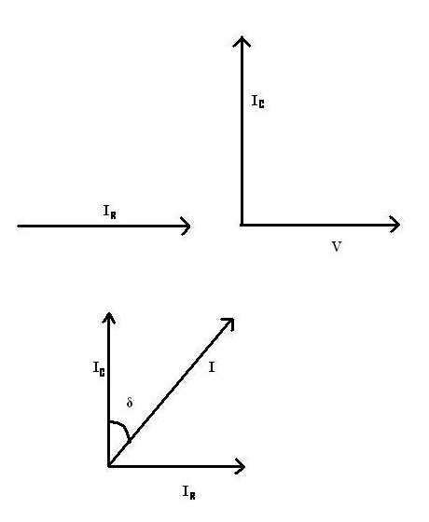

Dielectric Loss: VI_{R}
$$\cos\left(90-δ\right)=\frac{I_{R}}{I}$$
$$Isinδ=I_{R}$$
Loss=V$Isinδ$
$$cosδ=\frac{I_{c}}{I}$$
$$I_{c}=Icosδ$$
$$I=\frac{I_{c}}{cosδ}$$
Loss=$=V\frac{I_{c}}{cosδ}sinδ$
Loss=$VI_{c}tanδ$
$$I_{c}=\frac{V}{X_{c}}$$
where$X_{c}=\frac{1}{ωc}$= reactance of capacitor
$$ωc=2πfc$$
So $X_{c}=\frac{1}{2πfc}$
$$I_{c}=V2πfc$$
Loss= $V×V2πfctanδ$
Loss=$V^{2}2πfctanδ$

This is the equation for loss tangent.

Types of dielectric polarization
Based on different atomic mechanism polarization are of following type:-
- Electronic polarization: It results from the displacement of the center of negatively charge electron cloud relative to the positive nucleus of the atom by electric field. This shifting of electron cloud results in a dipole moment.
$$p=ql$$
Also $p$ is directly proportional to field strength E
$p=α_{e}$E
$α_{e}$is called electronic polarizabiliy.
This type of polarization is independent of temperature.
- Ionic polarization: ionic polarization occurs in ionic material. When electric field is applied to an ionic material cations anions get displaced in opposite directionwhich gives rise a net dipole moment.
$$p_{i}=ql$$
$$p_{i}=nα_{i}E$$
Where $α_{i}$ is called ionic polarizability.
- Orientation polarization: This type of polarization is found only in substances that posses permanent dipole moment. When an electric field is applied on such molecules then the dipole tend to align themselves in the direction of applied field. This polarization is temperature dependent and decreases with increasing temperature.

S.NO | RGPV QUESTIONS | Year | Marks
Q.1 | Explain dielectric loss. Obtain an expression for loss tangent for it. | Dec 2013 | 7

.

